Heading 2

Heading 3
Heading 4
Body Text — Arial 10pt 12/12; line spacing 1.18pt
Bullet list - level 1
  - Bullet list - level 2
    - Bullet list - level 3

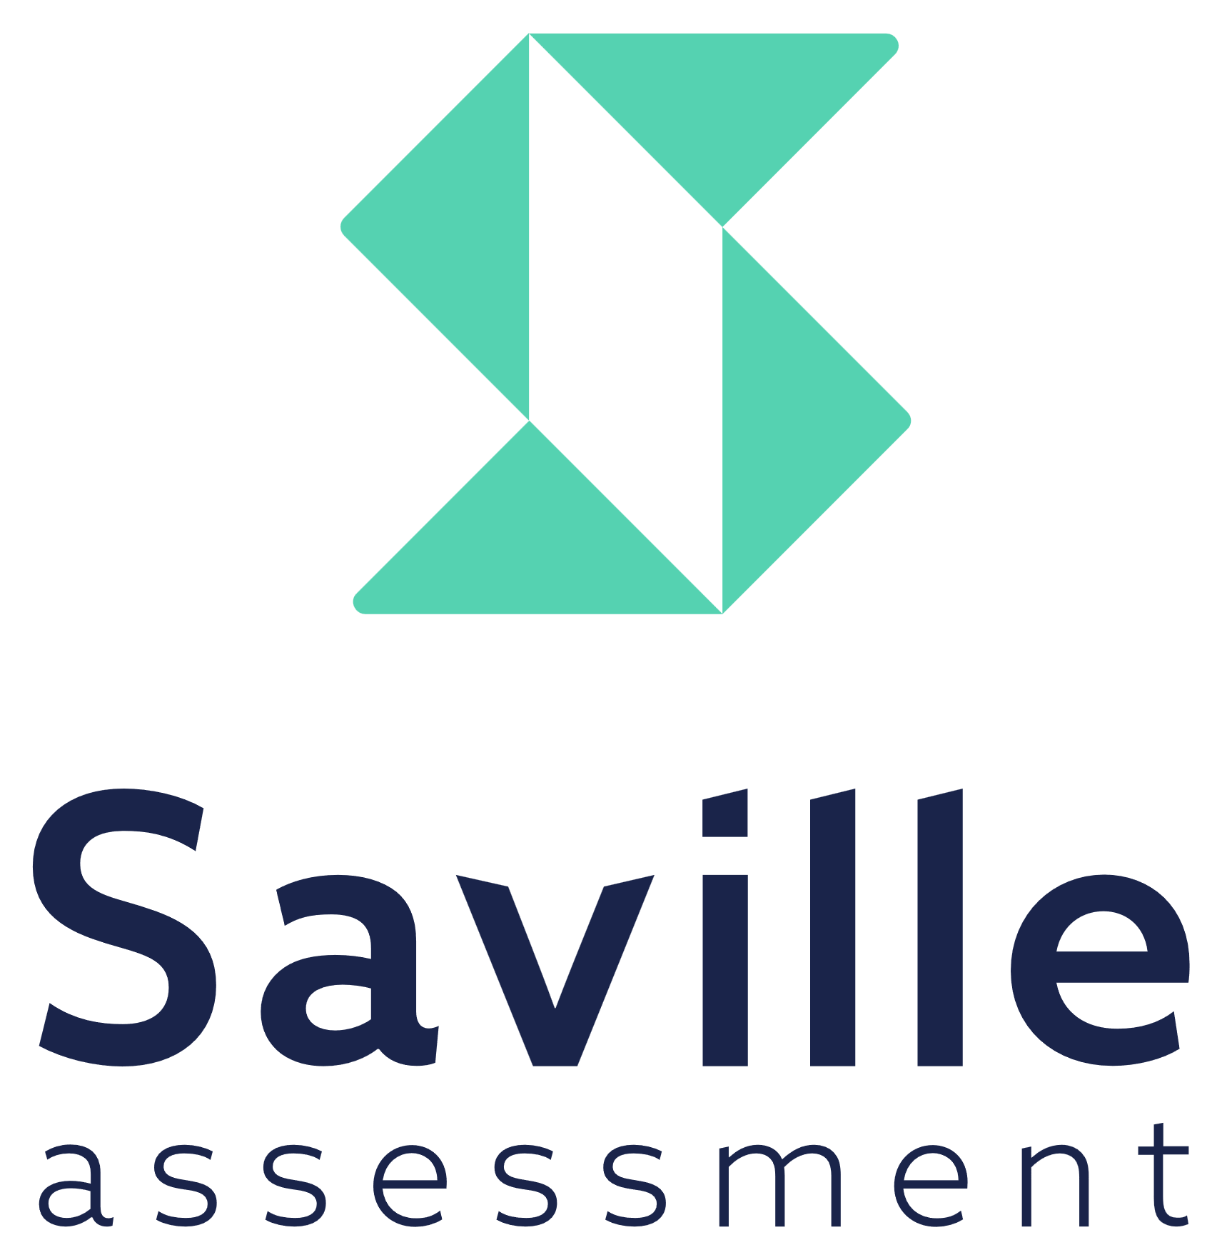

info@savilleassessment.com
www.savilleassessment.com

© 2023 Saville Assessment Ltd. All rights reserved.

